**Pitch Deck for Aviratha Digital Labs**

**Introduction**

* **Company Name**: Aviratha Digital Labs Pvt. Ltd.
* **Founded**: 2023
* **Mission**: Transform agriculture through innovative, sustainable, and scalable solutions.

**Problem Statement**

* **Challenges in Agriculture**:
  + Traditional farming methods are often inefficient and risky.
  + Smallholders, students, and first-time entrepreneurs face barriers in accessing modern farming techniques.

**Our Solution**

* **Technology-Driven Approach**:
  + Development of precision farming tools that are accessible and impactful.
  + Focus on making complex farming methods simple and repeatable for all users.

**Product Overview**

* **Core Offerings**:
  + A conversational AI assistant specifically trained for hydroponics.
  + Features include:
    - Nutrient, pest, and deficiency management.
    - Daily farm operations support.
    - 24/7 troubleshooting for crop-related issues .
* **Competitor Landscape**

|  |  |  |
| --- | --- | --- |
| **Competitor** | **Focus Area** | **Our Advantage** |
| UrbanKisaan | Urban Hydroponics | Rural reach + AIoT + VR + chatbot integration |
| Future Farms | Turnkey Hydroponics | Modular + training + support |
| Fasal | IoT for Traditional Farming | Hydroponic-focused IoT and immersive education |
| VRiddhi | VR Skill Training | Real-time AI + live farm data + chatbot synergy |

**Funding and Support**

* **Initial Funding**: Secured Rs. 5,00,000 (Five Lakhs) to develop and scale prototypes.
* **Goals**:
  + Validate field deployments.
  + Initiate regulatory and market engagement

**Market Opportunity**

* **Target Audience**:
  + Farmers, agri-entrepreneurs, and educational institutions.
* **Market Need**: Increasing demand for sustainable and tech-enabled farming solutions.

**Business Model**

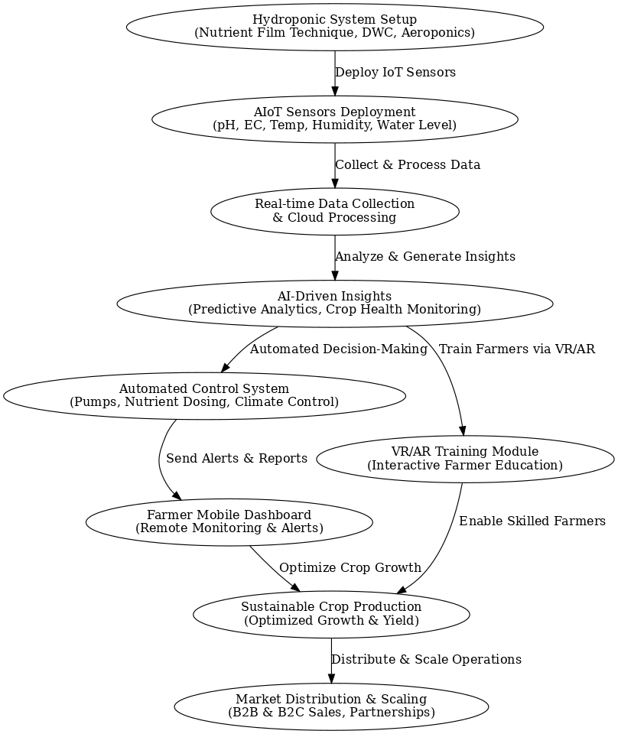

**Unique Selling Proposition (USP)**

* **Full-Stack Integration:** IoT + AI + VR + Chatbot in one ecosystem
* **Retrofittable Solution:** Upgrade existing farms, no need for costly infrastructure
* **Immersive Learning:** Hands-on training via VR simulations
* **24x7 AI Chatbot:** Regionally customized hydroponic guidance
* **Modular & Localized:** Adapted for Indian crops, languages, and climate zones

**Customer Benefits with Quantified Impact**

1. **20–30% Yield Increase** – via AI-optimized nutrient and climate control
2. **Up to 40% Cost Savings** – efficient use of water, nutrients, and manpower
3. **80% Faster Learning Curve** – VR-based hands-on training
4. **70% Query Resolution via Chatbot** – multilingual, round-the-clock support
5. **100% Soil-Free Cultivation** – enabling farming in degraded soil areas
6. **50% Lower Entry Cost** – modular, scalable, low-capex adoption path

**Financial Projections**

|  |  |  |  |
| --- | --- | --- | --- |
| **Year** | **Revenue (INR)** | **Expenses (INR)** | **Net Profit (INR)** |
| Year 1 | 20 Lakhs | 15 Lakhs | 5 Lakhs |
| Year 2 | 50 Lakhs | 30 Lakhs | 20 Lakhs |
| Year 3 | 1.2 Crores | 70 Lakhs | 50 Lakhs |

**Go-to Market Strategy**

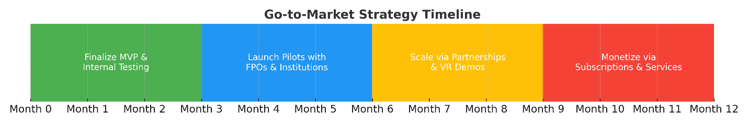

**Technologies Used in Aviratha Digital Labs Solutions**

Aviratha Digital Labs employs a range of innovative technologies to enhance agricultural practices, particularly in precision farming. Here are the specific technologies utilized in their solutions:

* **AIoT-Based Sensor Systems**:
  + These systems collect real-time data on various environmental parameters such as climate, pH, electrical conductivity (EC), and light levels. This data is crucial for making informed decisions in farming practices.
* **Automated Nutrient Dosing**:
  + The solutions include automated systems that use AI analytics to determine the precise nutrient requirements of plants. This ensures that plants receive the right amount of nutrients at the right time, optimizing growth and resource use.
* **Continuous Feedback Mechanisms**:
  + The technology provides continuous feedback to farmers, allowing them to adjust their farming practices in real-time. This feature promotes resource-efficient farming by minimizing waste and maximizing yield.
* **Immersive Virtual Reality (VR) Training Modules**:
  + Aviratha Digital Labs offers VR training modules that simulate greenhouse environments and farming workflows. This technology helps train farmers and agri-entrepreneurs in modern farming techniques in an engaging and interactive manner.
* **Domain-Specific Generative AI Chatbot**:
  + The company has developed a specialized chatbot that provides advisory services on hydroponic farm management. This includes guidance on pest control, nutrient management, and identifying plant deficiencies, making expert advice accessible to users at any time.
* **Community-First Approach**:
  + Collaborating with organizations like the JERBI Foundation, Aviratha ensures that their technology reaches underserved and rural farming communities, promoting inclusivity in agricultural innovation.

These technologies collectively aim to empower farmers and enhance agricultural productivity through precision farming, making modern techniques more accessible and effective.